Minimalism Video and Questions

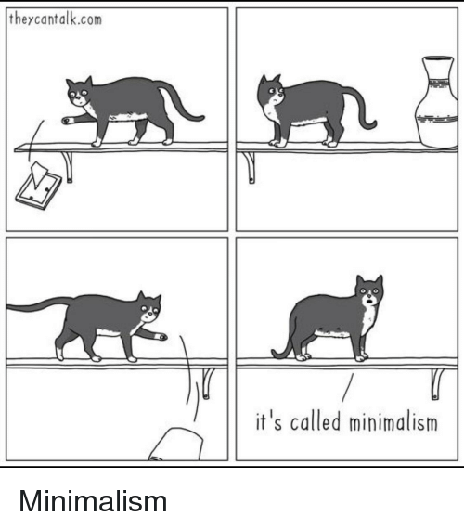
Video link: https://www.youtube.com/watch?v=jrf_dMnatW0

Instructions:
In class we have been talking about money. In connection to that, here is a video about minimalism. Please watch it and then answer the following questions. Submit your answers through Edmodo. You need to download the app and find our class using the class code qnhzhd.

- Write down 20 unknown words and expressions and their Hungarian meaning.
- What is minimalism?
- What do some minimalists do?
- Who are Josh and Ryan? What did they do?
- Do you think you could be a minimalist? Why or why not?

